**DAILY ONLINE ACTIVITIES SUMMARY**

|  |  |  |  |  |  |
| --- | --- | --- | --- | --- | --- |
| **Date:** | **10-06-2020** | | **Name:** | **Shah Dhruvil Amit** | |
| **Sem & Sec** | **6th - B** | | **USN:** | **4AL17CS083** | |
| **Online Test Summary** | | | | | |
| **Subject** | **SSCD** | | | | |
| **Max Score** | **30** | **Score** | | **29** | |
| **Certification Course Summary** | | | | | |
| **Course** | **Python programming** | | | | |
| **Certificate Provider** | **E-box** | **Duration** | | | **2 hours** |
| **Coding Challenges** | | | | | |
|  | | | | | |
| **Status: executed** | | | | | |
| **Uploaded the report in GitHub** | | **Yes** | | | |
| **If yes Repository name** | | <https://github.com/DhruvilShah99/Daily-Updates> | | | |
| **Uploaded the report in slack** | | **Yes** | | | |

SSCD IA-4

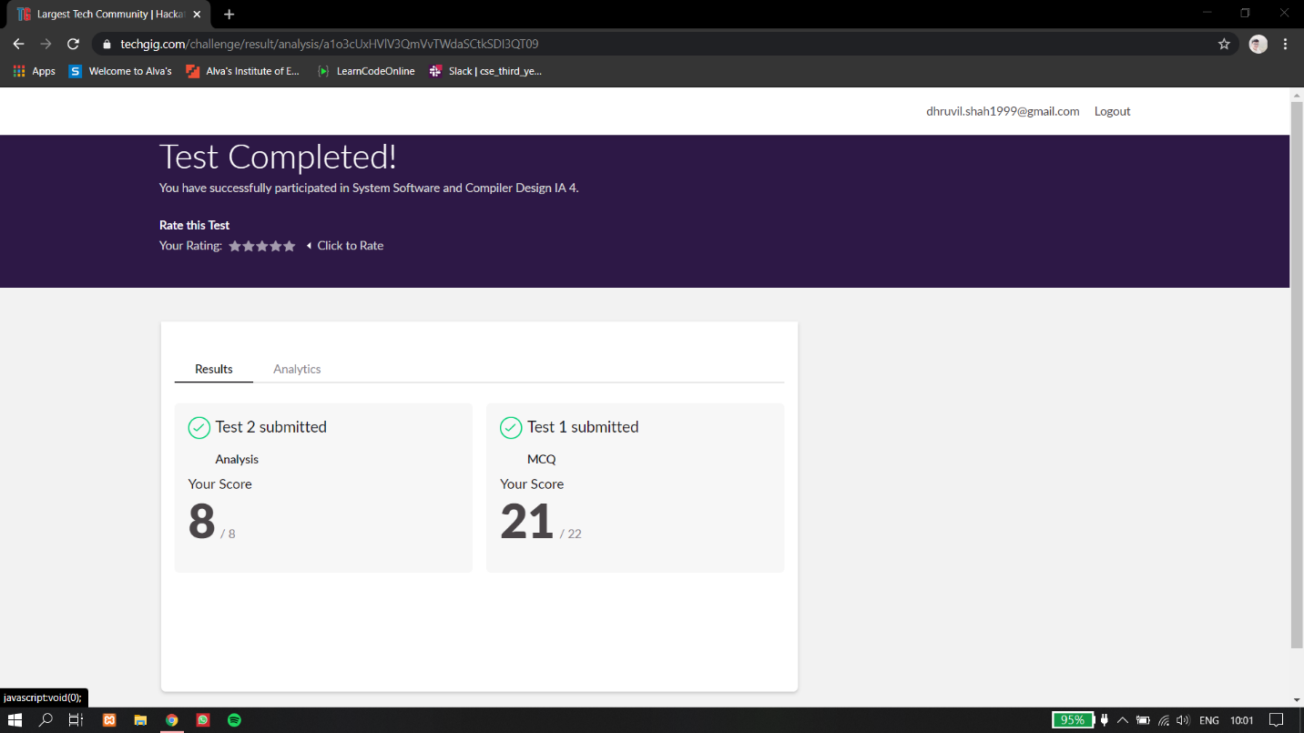

Certification Course Details:

Report-

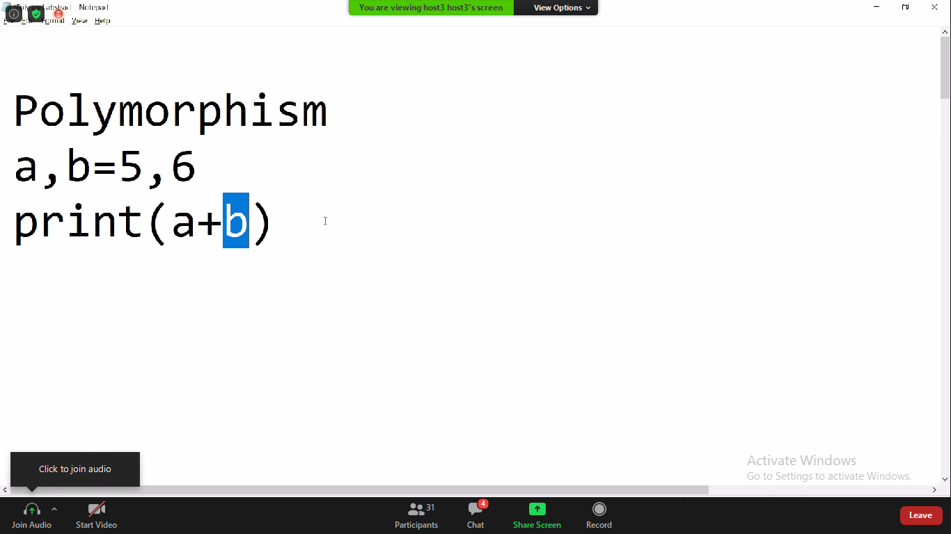

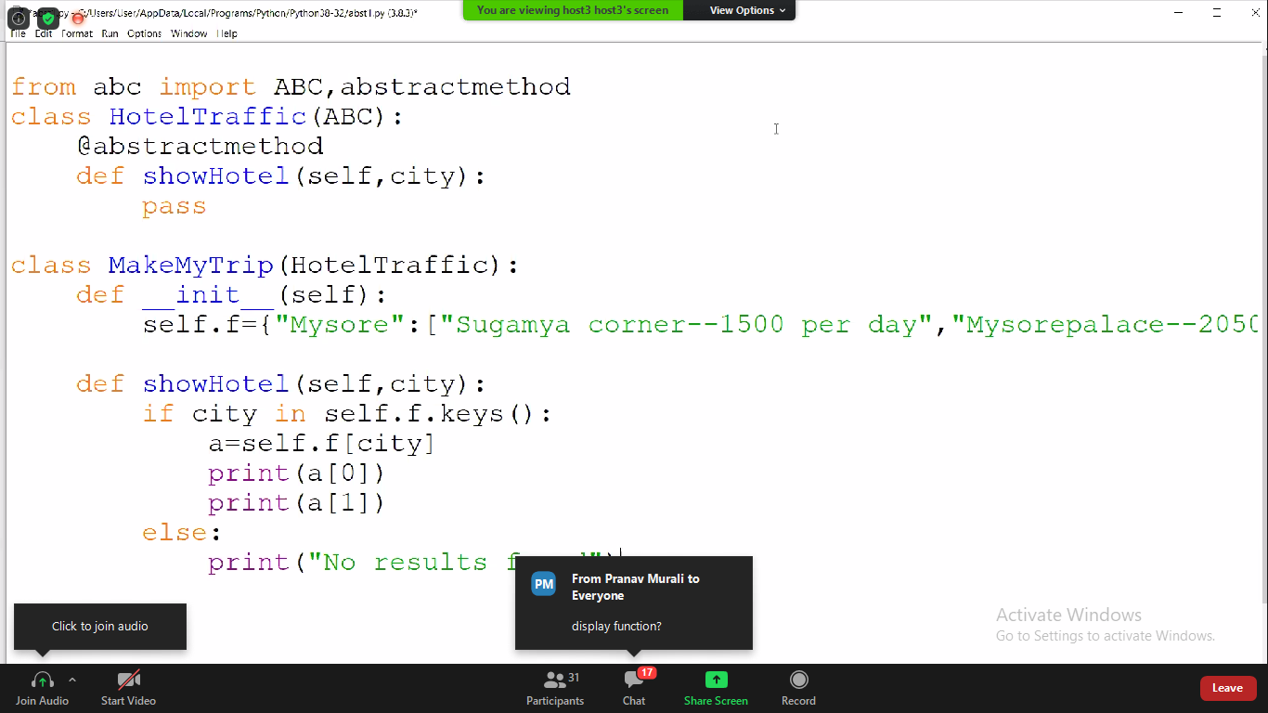

In todays session of online class, I have learnt about polymorphism and also the different use of polymorphism in function as well as class in python.

Coding Challenges Details:

The below GitHub link for details

<https://github.com/DhruvilShah99/Daily-Updates>

P-1

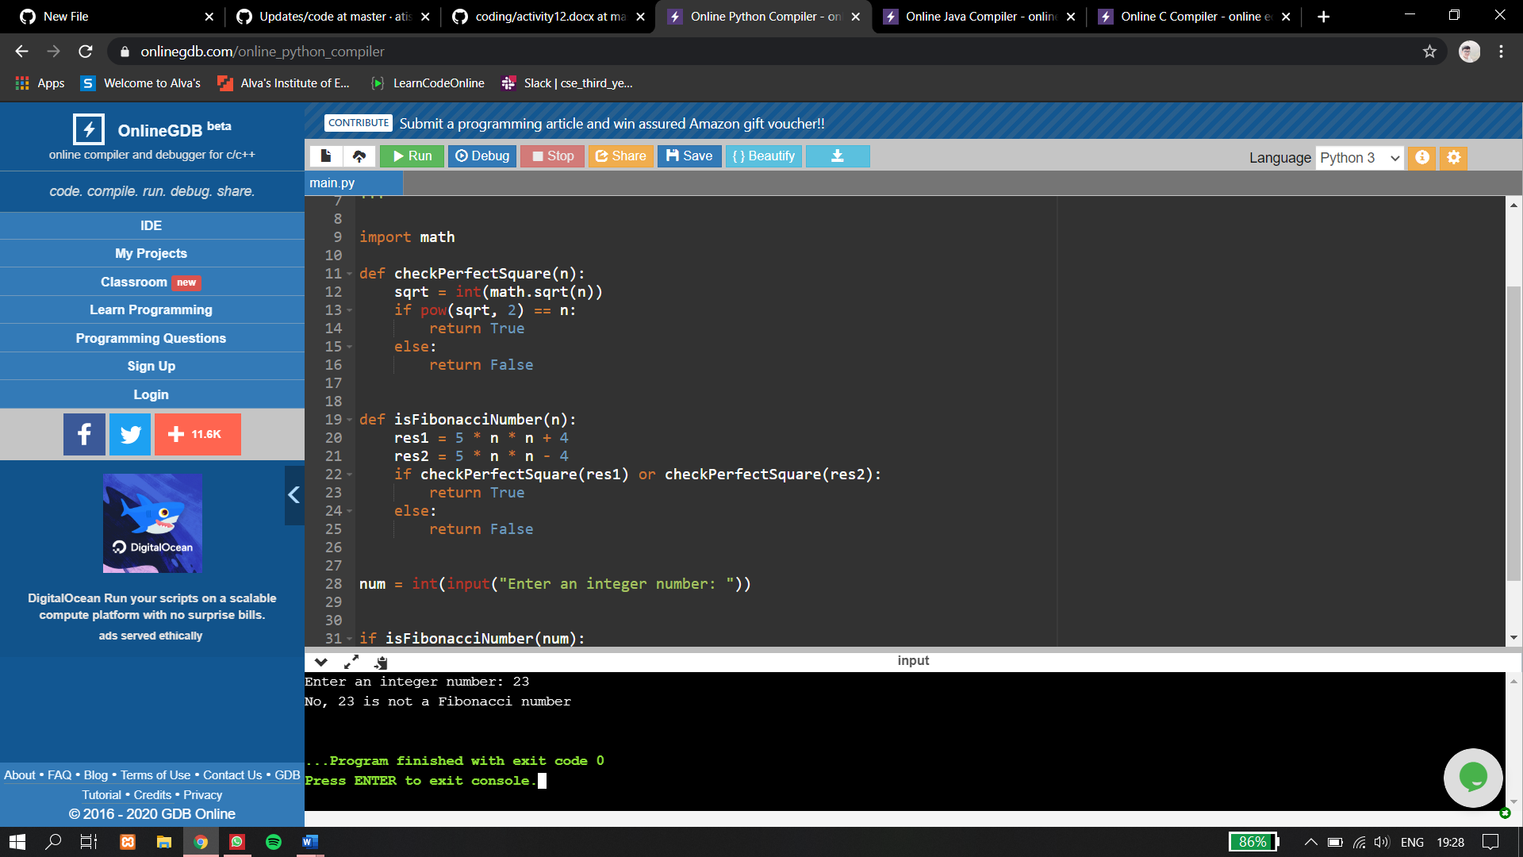

**P-2**

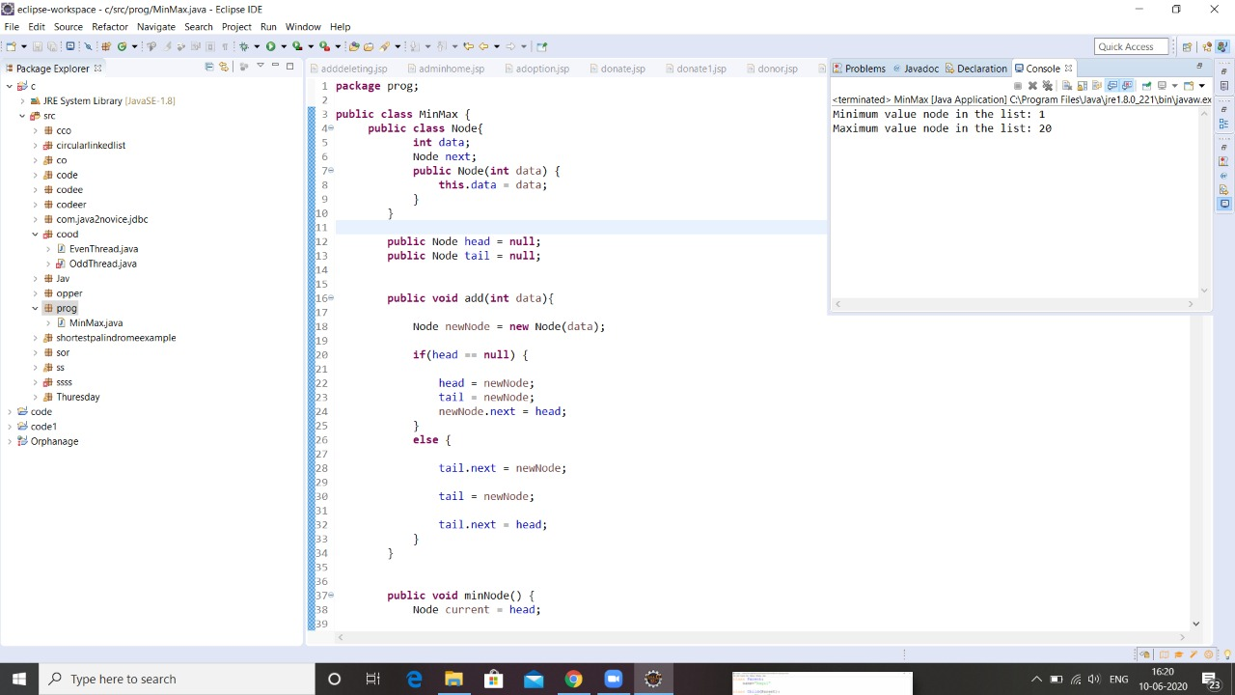

**p-3**

